### DESIGN PROJECT REPORTS OF Eter

### TITLE

**(TIMES NEW ROMAN, 12, BOLD)**

Team Name：Alibaba

Wang lindeng

Cao weina

Qin yankun

Zhang yuxia

Ouyang huiying

Date (Times New Roman, 12)

*Abstract*

With the rapid development of information technology, people are paying more and more attention to academic qualifications. Under this background, postgraduate entrance examination has become a good way for people to improve their academic qualifications. As far as the existing software for postgraduate research in the market is concerned, it contains many majors, but the software for postgraduate research in educational technology has not yet appeared on the market. The development of this software provides a platform for information exchange and knowledge learning for the majority of graduate students majoring in educational technology. It is more conducive to a special and targeted review and improve the success rate of graduate students.

# Introduction (Times New Roman 16, Bold, left)

Set the context: According to statistics of the number of candidates for postgraduate admissions over the years, the number of candidates for postgraduate admissions has increased year by year, as shown in Figure 1-1. In recent years, with the sharp increase in the number of candidates for postgraduate entrance examinations, it is mentioned in "Analysis of Current Situation of Postgraduate Entrance Examination for Graduates and Related Countermeasures" that postgraduate entrance examination has become one of the main choices for college students [1]. The convenience brought by mobile phones in people's lives has been continuously improved. More and more companies have begun to attach importance to the design and development of response apps. Various word memory software, problem-solving software, and forums have emerged at the historic moment. At present, there are many APPs on the market for postgraduate research. Common apps include the postgraduate gang, pocket question bank, chalk postgraduate research, and similar English-language apps. In view of the chaotic situation of the postgraduate app in the market and the potential market potential, the team learned about the current use of the postgraduate app, user experience, functional requirements of the postgraduate app, and user expectations for the postgraduate app, and found that there is currently no A postgraduate app for a particular major, and most of the postgraduate app does not involve educational technology majors or it is difficult to obtain effective professional postgraduate information.

• Explain the purpose: There is a broad market demand for specific postgraduate apps designed for niche majors. It can provide targeted learning support and services for postgraduates who choose a particular specialty in a school, so that postgraduates can Learn better. In addition, as a graduate student in educational technology, we are also committed to promoting the learning and development of our profession, so we designed such a postgraduate app, Eter, which is dedicated to educational technologists.

• Set the scope: There are three main needs for postgraduate students: postgraduate research materials (including video, PPT, books, etc.); experience of postgraduate students; postgraduate information for each school [2]. The postgraduate app for educational technology postgraduate students designed by our team is very clear for Eter who has selected a certain target college. For the target college he chose, he provided special learning support services for educational technology courses, allowing Eter to have a plan and direction in the study of educational technology courses in the process of educational technology examination and research, and to obtain a good learning experience. On the way to school.

• State the objectives: Create a postgraduate app dedicated to educational technology postgraduates, and provide Eter with information on colleges and universities, postgraduate exam questions, training, and exchange communities. For each Eter's learning activities on this app, our app will obtain relevant learning data and use educational big data to provide learners with more personalized and intelligent learning services.

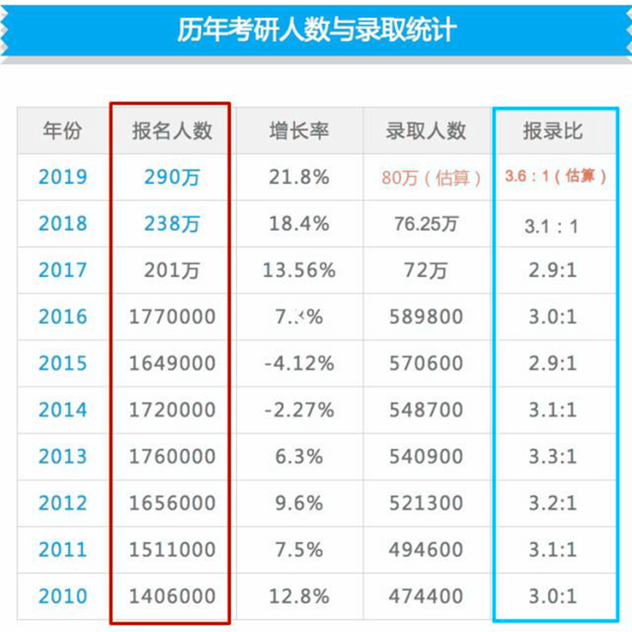

Figure 1-1 Statistics of the number of graduate candidates over the years

# Customer Needs Assessment

A customer needs assessment uncovers the precise needs of customers, how these needs are (or are not) currently being fulfilled, and what is required to improve satisfaction and loyalty.Base on this principle,the customer needs assessment of our project went through four phases：the iterative process for defining the customer , developing appropriate interview and observation guides, collecting data, and converting it to customer requirements statements.

AHP decomposes the problem into different constituent factors according to the nature of the problem and the overall goal to be achieved, and aggregates and combines the factors according to different levels according to the interrelationship and affiliation of the factors to form a multilevel analysis structure model, so that the problem finally comes down to the determination of the relatively important weights of the lowest layer (decisions, measures, etc.) relative to the highest layer (overall goals) or the ranking of the relative priorities.According to C.K.KWONG,the essential steps in the application of AHP contains(1)decomposing general decision problem in a hierarchy fashion into into sub-problems that can be easily comprehended and evaluated,(2)determining the priorities of elements at each level of the decision hierarchy,and(3)synthesizing the priorities to determine the overall priorities of the decision alternatives.

* 1. Define the customer

From the beginning, our goal is to develop a learning software for students majoring in Educational Technology who are preparing for postgraduate entrance examination.So the customers are defined as two categories:the learners who are preparing for the postgraduate entrance exams of educational technology and the students who have passed the postgraduate examination of educational technology(mainly for the learners who are preparing for the postgraduate entrance exams of educational technology).

* 1. Develop appropriate interview and observation guides

Our interview guides was based on observations guides,including 10 questions,Some questions are about the user's previous experience, and some are about suggestions for relevant software(Yon can find both interview guide and observation guide in the appendix).

* 1. Collect data: Our field work

1. Customer interview

Our one and a half hour in-depth user interviews in classroom enabled us to gain deeper insight about who they were and the reality of their learning beyond discreet topics. We asked questions that we had designed in advance such as their learning style,the experience of postgraduate entrance examination and their expectations of our platform. Only after understanding these things, did we explore how the ETer fit in.

1. Expert interview

Interviewing experts helped us identify the structure design of learning platform,and set the baseline of knowledge that informed our design process.

1. Extend observation

While in-depth interviews increased our understanding, adding in-context observation brought even deeper insights. With a few customers,we followed them through the entire process of using relative learning platform,we were able to understand their expectations and requirements.

Though interviews and observations,we obtained the data that we need.Next,we collated the data to get the the initial customer need list.In order to more accurately understand the needs of users,we work together to improve the initial table.Finally,we got the second table,which list the hierarchal design objective list and has been augmented with constraints and functions.

### Table 1. Initial Customer Needs List Obtained from Interviews and Observations (Times New Roman, 12, Bold, Centered)

|  |
| --- |
| **Able to take notes in the process of learning** |
| **Relevant recommendations** |
| **Mobile learning** |
| **Able to search resources** |
| **Online discussion** |
| **Professional** |
| **Institutions Introduction** |
| **Able to record the error correction** |
| **Self-knowledge construction** |
| **Expert Introduction** |
| **College information of the major** |
| **Relevant links** |
| **Easy to use** |
| **Help and feedback** |
| **Interaction** |
| **Collect favorite contents** |
| **Previous examination papers** |
| **Bibliography** |
| **Exercise bank** |
| **Simulation test** |
| **Simple and clear interface** |
| **Provide accurate resources for students** |
| **Content-rich** |
| **The resources updated in time** |
| **Clear function button** |
| **The quality and quantity of resources are guaranteed** |
| **Privacy** |

**Table 2. Hierarchal Customer Needs List (With Weighting factors) (Times New Roman, 12, Bold, Centered)**

|  |
| --- |
| **1.Practicable** |
| **1.1 Exercise bank** |
| **1.2 Simulation test** |
| **2.User friendly** |
| **2.1 Interface** |
| **F.1 Simple and clear interface** |
| **F.2 Clear function button** |
| **2.2 Easy to use** |
| **2.3 Privacy** |
| **2.4 Self-knowledge construction** |
| **3.Content-rich** |
| **3.1 The quantity of resources are guaranteed** |
| **F.1 Previous examination papers** |
| **F.2 Expert Introduction** |
| **F.3 College information of the major** |
| **F.4 Institutions Introduction** |
| **F.5 Bibliography** |
| **3.2 Relevant links** |
| **3.3 Professional** |
| **3.4 The resources updated in time** |
| **4. Interactive** |
| **4.1 Able to search resources** |
| **4.2 Provide accurate resources for learners** |
| **4.3 Online discussion** |
| **4.4 Relevant recommendations** |
| **4.5 Help and feedback** |
| **5.Personal information management** |
| **5.1 Collect favorite contents** |
| **5.2 Able to take notes in the process of learning** |
| **5.3 Able to record of error correction** |

* 1. **Weighting of Customer Needs**

The weight refers to the number of times the labeled value of each group appears in the variable sequence. It is the carrier of the variable value and reflects the influence of the labeled value of each group on the average. The function of weight is to reflect the proportion of each group of units in the total unit, and is widely used to calculate the average and index.

We used the fourth-order analytic hierarchy process.Experts are invited to make judgments on the relative importance of each factor in each level. These judgments are quantified by introducing appropriate scales to form a judgment matrix.

**3.0 Revised Needs Statement and Target Specifications**

## (1) This work adopts Axure RP 8 for UI design, which is applicable to IOS system. UI design specification for IOS system:

## Interface design dimension and column height

## Retina screens are used in IOS devices. Different iPhone devices have different physical sizes and resolutions. In addition, IOS strictly regulates the height of each column. The main specifications are shown in Figure3-1.

## 

## Figure3-1. Bar height specification

## Margins and spacing

## Global margin: the value of the full margin is even, and the commonly used global margins are 32px, 30px, 24px, 20px, etc. 30px is the most comfortable distance, which is the first choice for most applications. Another is to leave no margin, which is usually used in the card layout to display the picture column.

## Card margin: card layout is a very common layout method in mobile page design. As for the setting of the distance between card and card, it needs to be defined according to the interface style and the amount of card bearing information. Generally, the minimum is no less than 16px, and the most used spacing is 20px, 24px, 30px, 40px. The spacing should not be too large. Too large spacing will make the interface loose The color setting of the spacing can be the same as the split line or lighter.

## Content spacing: when content layout in UI design, we must pay attention to the application of proximity principle. According to the Gestalt proximity principle, the relative distance between individual elements will affect our perception of whether and how they are organized together. The elements close to each other appear to belong to a group, while those far away are automatically divided into groups, which are closely related.、

## Content layout

## List layout: when using list layout, pay attention to the minimum height of list comfort experience is 80px, and the maximum height depends on the content.

## Card layout: the card layout is flexible. The contents and forms of each card can be independent of each other without interference. Different cards can appear on the same page and carry different contents

## Design scale of interface pictures

## Common picture sizes are 16:9, 4:3, 3:2, 1:1 and 1:0.618, etc。

## Icon design

## A set of APP icons should have the same style, including modeling rules, fillet size, wireframe thickness, graphic style and individual details and other elements should have a unified specification。

## App layout design specification

## Alignment, symmetry and grouping

## Interface text design specification

## In an app, the font size range is generally between 20-36 (@ 2x). All font size settings must be even, and the range of font size between upper and lower content is 2-4. The color of font generally uses dark gray and light gray, thin and bold (pay attention to the font's own word weight, not the bold function of PS) to distinguish important information and secondary information, and to divide the information level.

## Figure3-2.Font application chart

## (2) User requirements

## Initial demand: provide information of relevant institutions for postgraduate entrance examination; find materials for preparation for examination; conduct professional practice; have research friends to exchange and study; answer questions; be able to trade second-hand books and materials; provide links to relevant journals and papers; conduct personalized recommendation.

## Demand after probation: Ability test is placed in the University: conservative and risk recommendations and related suggestions are recommended, mainly in objective questions; Content of ability test: questionnaire survey (major, discipline,), adding the elder and elder sister's Q &amp; A link, the home page and evaluation can be combined; True questions: presented by year; Relevant knowledge points are refined, and prediction questions can be added; Community (refer to Baidu) Post Bar): keyword search, and the community can be divided into large community and small community; Course: join the courses of famous teachers of relevant institutions; Bibliography: there are official and recommended; Exercise questions: divided into chapters, such as the separation of theory and computer.

## Based on the above UI design specifications, user needs, we have completed our platform construction, mainly including "home page", "community", "evaluation" and "I"。

## Home page:

## The main functions of the home page are search, real title and reference links, countdown reminders. The core part is the link between the real title and the bibliography. In this part, we collect the real title and bibliography of each university in the past 15 years.

## 

## Figure3-3.Home page

## Community:

## Community module we provide users with a platform for communication. Users can create their own comments and watch others' comments anytime and anywhere. At the same time, they can use the search function to find their own interested comments in time. Of course, we will also recommend for learners, and learners can choose "hot" topics and discussions on their own.

## 

## Figure3-4.Community

## Evaluation:

## The evaluation part mainly provides a platform for learners to practice. The module includes two modules, namely "simulated real problem" and "practice". According to different professional courses and different difficulties, it can meet different learners' exercises at different periods.

## 

## Figure3-5.Evaluation

## I:

## This part shows all kinds of information of users on the platform, including personal information, collection, error collection, notes, etc. at the same time, we will also collect feedback data of users in this part to improve the platform.

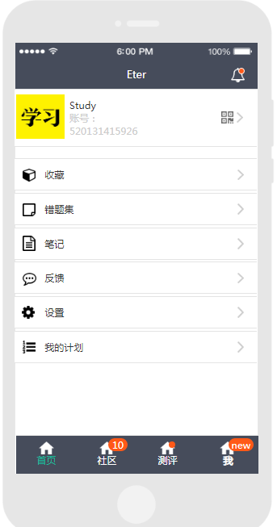

Figure3-6.I

# External Search

## Resources

## First, get our inspiration: from real life problems and the use of existing practical products, as students of educational technology, we have many problems that are not easy to solve in regular college classes. Especially in the individual independent learning process, such as personal research, postgraduate entrance examination and other issues.

## Determine product direction: after the communication with teachers and classmates, after group of deliberations, we decided to do a about: "education technology students one's deceased father grind need APP".

## Third, the design source of core design functions

## (I) interface design problem: source and actual observation of existing products. The pages of existing products are complex and not suitable for the demand-oriented postgraduate students who focus on usefulness.

## (ii) core issues :(system statement for product, process and system revision)

## 1. Give a list of schools.

## Design comes from understanding the user's needs. Through the communication with the target users, we found that the users have great needs for all schools of educational technology.

## Features implementation sources, Internet educational technology school searches and library books on educational technology.

## 2. The school's bibliography is presented

## Design comes from user research needs

## Function realization source, the examination outline that the school issues on the Internet.

## 3. Present the exam questions

## Design source; Related learning theory

## Function realization: communication with school, etc

## Business opportunity statement

## (1) product overview: this product serves students who will participate in the postgraduate entrance examination of education technology major. It takes Internet APP as the framework to present the learning contents including college selection, test of real questions, simulation training and other learning contents, and provides services including learning record, learning plan recommendation, learning knowledge summary and so on. Solve the current situation of postgraduate students because there is no topic to do, improve their professional quality and skills.

## Product prototype statement:

## Form: APP application

## Product or service functions: college selection, real problem simulation, simulated training, knowledge push, learning plan arrangement, knowledge summary, learning community and other services.

## (3) value

## Value for postgraduate students: for students who are going to take part in the postgraduate entrance examination but have no idea of how to proceed, we will provide services in the whole process from deciding to take part in the postgraduate entrance examination to entering the postgraduate entrance examination. We will help them to find out the most suitable universities for them to pursue their dream. Through mind mapping, cognitive law and learning analysis, we will get the individual learning situation and make scientific planning.

## (4) market evaluation

## Macro market evaluation: through the above analysis, there is a lack of specialized niche products such as educational technology in the whole postgraduate entrance examination market.

## Micro market evaluation: accurate positioning, clear objectives, high demand.

## (5) the competitor analysis: currently, no similar products, but there are potential competitors. With the improvement of some general entrance examination apps, the integration of educational technology into the service of the platform will pose a great threat to the product.

## The chart I made

## (6). After comparing the advantages of: 1. Colleges and universities to choose from. Based on the learner-centered learning style, undergraduate courses, and future development direction of all colleges and universities, the paper proposes alternative Suggestions for colleges and universities. Second, full information. Includes information on all institutions in the field. 2. Improve learners' learning. Use mind map knowledge summary, quick introduction, master the core areas. Providing correct answers to each question is crucial for a competitive exam. Wrong topic knowledge summary, from the wrong topic, summary often wrong knowledge, summary push. Learning plan arrangement, according to individual learning progress and knowledge master star mania and memory rules. Arrange learning schedule. 3. Learn from the community, exchange ideas and make progress together.

## Benchmarking

## And the comparison of special functions of products of the same type

|  |  |  |  |
| --- | --- | --- | --- |
| **Feature** | **Kao yanbang** | **Fenbi kaoyan** | **Kao yan youtiku** |
| Education technology professional | yes | Null | null |
| past exam paper | Null  Not have this module | Yes(for common required course ) | yes(for common required course ) |
| post | It has a big BBS,But not have this subject | Some articles, unclear source | It has a big BBS,But not have this subject |
| exercise | null | Yes(for common required course ) | Yes(for common required course ) |
| Summary of knowledge | null | null | null |
| Review schedule | null | It has record,but doesn’t have push schedule | null |

## The system will have all the features

|  |  |  |  |  |
| --- | --- | --- | --- | --- |
| Homepage | Main function | Function 1 | Function 2 | Function 3 |
| First page | Colleges and universities to choose | List of schools to choose from | Questions and references |  |
| Ability to test | Doing test | Report the results | Questions and bibliography |
| bibliography | List to choose | A mind mapping of the book | A mind map of a knowledge point | Do test and join study plans |
| community | Posting |  |  |  |
| Select all or user exam school posts | Collection, attention |
| Past exam paper | Choose one of the exam year | Start exam |  |  |
| Choose one subject |
| test | Choose exercise questions and practice questions | The exercises are objective and subjective | Do the questions according to the knowledge | |
| Collection/Add notes | |
| explain | |
| Do the same type of problem | |
| The simulation questions are divided into elementary and advanced | Elementary and intermediate and advanced | |
| Users of own page | collection | Collected topics and posts (showing recent ones) | All posts | Browse specific posts |
| According to the collection of professional courses to present the number of topics and can browse | |
| Wrong topic set | By subject | If you make a mistake, you can choose to show or not show the correct answer and the parsing | |
| notes | By subject | Record the time and content of your notes. Edit your notes | |
| feedback | Input feedback and submit、Show feedback successful | | |
| Set up the | Changes in personal information | Avatar and nickname changes and uploads | |
| privacy | Set post update reminder, view my post, get our study record, authorization management switch | |
| general | Enable landscape and portrait, automatically download the latest version, font size, download management, memory cleaning | |
| About the development team | View team profiles, team values, events, copyright notices, contact us | |
| Content push switch | | |
| My plan | Recent learning | Choose the study records of recent days, weeks and months, including visualized time proportion chart and wrong questions chart | |
| Push plan by knowledge point | The number of wrong questions in the subject and the knowledge points under the subject will push the learning content and add him to the learning plan | |
| Ebbinghaus forgetting curve arrangement | The number of wrong questions in the subject and the knowledge points under the subject will push the learning content and add him to the learning plan | |

## Applicable Constraints

## First of all, what we need for the project

## Internal factors:

## Human resources and professional knowledge: operation, data analysis technicians, art engineers, system maintenance personnel, who have professional knowledge of educational technology, but also learn about the design of online learning platform.

## Budget: at present, the budget is still small, which is in the design period of the project. If it is really realized, it needs about 300,000.

## Space: server.

## External environment:

## Market: mainly for the majority of Chinese postgraduate students. At present, there are no similar competitive products in the market, and the number of potential users is large, there is a huge demand.

## Environment: the promotion of academic degree is one of the main flows of undergraduate graduates in today's society. At the same time, the lack of resources is a major problem for students who want to study in educational technology. In addition, the environment of research and development is good, and the Internet industry develops rapidly. Mobile learning and online learning have become one of the main forms of college students' learning.

## Theoretical support: ubiquitous learning theory, knowledge construction theory, learning-related psychological theory, mind mapping and other knowledge present the development of relevant theories, which has become the basic principle of our project design.

## Technical support: big data technology, learning analysis, machine learning, etc. provide technical support for simulating user portraits, extracting information from data, and providing services of rapid positioning, rapid response and accurate push

# The KIEBIE analysis of you learning platform

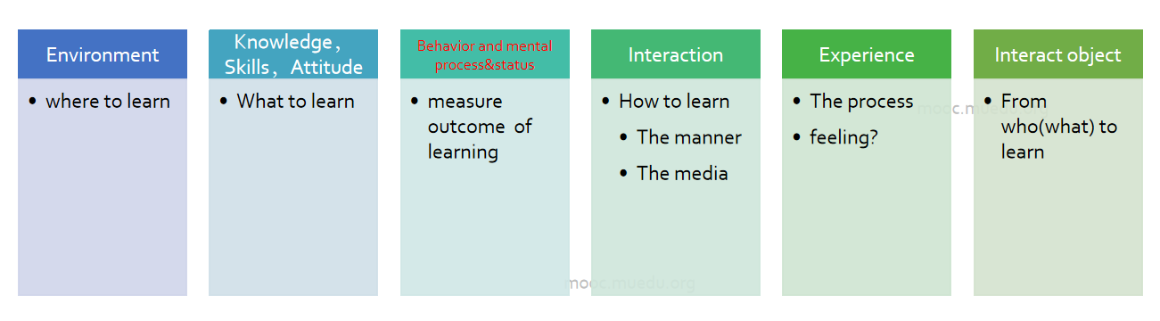

### Figure 2. KIEBIE

## Environment

## Our environment is a software developed based on the Android system, the main purpose is to serve the graduate students of educational technology.

## First of all, the reason why we chose to make a software instead of a web application is that it is more convenient and faster for graduate students to use mobile phones, and at the same time, questions and communication on mobile phones are more fragmented.

## Secondly, our environment mainly integrates functions such as resources, communication, evaluation and setting. Let's talk about resources first. Our resources mainly include the real questions and recommended books of major universities. After students register and log in, our software will send related information such as the number of candidates for postgraduate studies, hot spots for postgraduate studies, and famous teachers And other information.

## Third, our environment is a set of exchanges, students can discuss in the discussion area, to achieve the exchange and interaction of the same professional, more targeted.

## In addition, our assessment is also an important aspect of the environment. Students can evaluate according to their needs in the assessment. The assessment can be performed either by knowledge points or by real questions.

## What we achieve is a software based on Internet + education, and its operating environment must rely on the Internet and big data. It is precisely the advantages of our software environment. One is to make our education technology graduate students more targeted to study, and the other is to enable students to conduct extensive social interaction in the community.

## Knowledge,Skills,Attitude

## We are a software developed for the entrance examination of educational technology students, so our main function is to serve the entrance examination. Of course, non-graduate education technology students can also learn some knowledge in the software.

## When it comes to the dimension of knowledge, the main purpose of our software is to allow students who have graduated from educational technology to learn more about the target college's knowledge, proportion hotspots, related book content, and real questions.

## As for skills, the use of this software helps to cultivate students' skills in using software to explore educational technology knowledge. As a student of educational technology, students should think more about how to integrate education and technology. The use of this software, On the one hand, students can use technology to learn knowledge, on the other hand, they can cultivate students' thinking of integrating education and technology.

## In terms of attitude, students of educational technology can take advantage of fragmented time to learn. By using this software, students can develop their information literacy and their attitudes to using technology to learn.

## Behavior and mental process&status

## The behavior of the software mainly includes some behaviors of learners and some behaviors of platform developers.

## The learner's behavior mainly includes learning behavior, learner's assessment behavior, learner's discussion behavior and feedback behavior.

## The learning behavior of learners means that educational technology students can use the software to learn the test sites and hotspots of target institutions, and to view bibliographies and real questions on the platform. At the same time, learners can search for relevant knowledge. For example, learners can Search for "learning analysis" on the platform, and the software will feedback the knowledge about "learning analysis" from the background database.

## In addition, learners' assessment behavior means that learners can test and practice in the assessment section. For example, the learner can practice the knowledge points, and can also evaluate according to the form of the real question, so as to achieve the grasp of a certain knowledge, and can also grasp the status of his current learning.

## The discussion behavior of learners is mainly for the community section. In this section, learners can choose the community of the target college and all communities, post and discuss, and read other people's posts to understand the higher degree of attention. Posts and ideas to construct knowledge.

## Finally, the learner's feedback behavior refers to the feedback of the software's suggestions.

## Interaction

## The software's interactions include browsing, searching, learning, testing, discussion, and feedback.

## The first part of the interaction is that the software will push related information, such as hotspots, famous teachers, etc. according to the target college selected by the learner. Learners can browse for learning.

## Search interaction means that the learner learns what he wants to know through a search query.

## Test interaction means that the learner performs tests based on knowledge points or real questions, and thus feedbacks the current learner's learning status and knowledge mastery.

## Discussion means that learners interact through the target college and the community of all schools to learn about the most popular posts and the people's most concerned content.

## The interaction of feedback is mainly for the software itself. Learners can give feedback with any suggestions.

## Experience

## For experience, our software will give students a good sense of experience in terms of learning content, learning resources, community discussions, and assessment experiences.

## First of all, as far as learning content is concerned, most of the current postgraduate research software is relatively large, and the software for educational technology postgraduate research has not been developed. Therefore, the greatest experience that our software brings to learners is the learning content. More targeted, restful learning is more targeted.

## Secondly, in terms of learning resources, our software integrates the real questions, bibliographies and related resources of major universities. Learners can not only learn the content on this software, but also find relevant information about the tutor and hotspots in the school. Learners can learn about the school in advance, which is more convenient and specific.

## Furthermore, we have fully considered the characteristics of the students in terms of community experience. Some students want to have interactive discussions with students who have graduated from educational technology in the same target college, while others do not want to communicate with their competitors. Therefore, our software fully takes this into consideration, allowing learners to choose for themselves, both the community of the target institution and the community of all institutions, which greatly guarantees the learner's ideas.

## In terms of the evaluation experience, we have fully considered the characteristics of different students. Some students want to evaluate according to knowledge points (ie chapters) while others want to evaluate according to the form of real questions. This software fully considers the characteristics of students, allows students to choose independently, and increases the freedom of students.

## 5.6 Interact Object

## The software mainly includes three kinds of interaction objects: learners, platform managers and others.

## For learners, we have a community that can provide learners with a space to interact with other same learners. Learners can discuss and communicate with other learners to achieve a deeper understanding of a certain knowledge. .

## For the platform managers, the learners can give us relevant suggestions, and our platform managers can adjust according to the learners' suggestions.

## For other people, there will be seniors and sisters in the community to answer questions and communicate with learners. Learners can learn more about the knowledge learned by graduate students through this link.

# Learning Theory

## What learning theory do you mainly applying

## Our research theories include knowledge construction theory, flow theory and connectivity theory.

## First of all, for knowledge construction theory, knowledge construction is completed by learners through the interaction between new and old knowledge experiences. In this process, learners' extensive and rich knowledge background will participate in this interaction, affecting the construction of knowledge.

## Second, our second theory is the flow theory. It is defined as the pursuit of happiness or fulfillment of one's desire for achievement, focusing on the activity itself without being affected by other things, and being willing to complete the task, thereby entering a state of selfless euphoria.

## Finally, our software is based on connectivity. Connectivism believes that learning is no longer a person's activity, but a process of connecting specialized nodes and information sources. Learning is a process of connection. The objects connected are nodes and information sources.

## Why do you applying this(these) theory

## First, for constructivism, in our software, learners can learn new knowledge on the platform, learners interact with new knowledge and old knowledge, and learners can interact with people in the community in the same profession , Interact to construct knowledge and form your own knowledge.

## Secondly, for the theory of flow, our software provides a special learning software for students who have graduated from educational technology. At present, there are many softwares for postgraduate entrance examinations, but the software for postgraduate entrance examinations for education technology has not yet appeared. Take the software for postgraduate entrance examinations, for example, there are very few contents related to educational technology. Therefore, the development of our software will improve the student's immersion in learning, and students can more easily learn the knowledge, hotspots and real questions of the target colleges on the software, and increase the flow experience of the learners.

## Finally, in terms of connectivityism, our software connects learners with knowledge, and learners can clearly know where they are, such as their mastery of knowledge and the location of knowledge. Learners can first learn on their own internal network, such as searching for relevant knowledge, learning related content, and performing related assessments. Secondly, learners can study on the external network, that is, the community, and learn more about the content of other candidates. In order to master and learn the knowledge, and ultimately form their own knowledge.

# Technology applying

## big data

## Big data technology refers to the application technology of big data, including all kinds of big data platforms, big data index system and other big data application technologies. Our platform adopts big data technology system, including some basic technologies, such as data collection, data preprocessing, distributed storage, database, machine learning, parallel computing, visualization and other technical categories and different technical levels. Our big data technology is mainly used to collect, process and provide feedback on learners' learning data. For each learner's data, it starts from the time when the learner enters the ability test. In the later use process, it continues to collect data including learning time, error rate, collection preference, etc. we store these structured and unstructured scattered and meaningless data collection in the data warehouse, integrate them together, and integrate these data to carry out Analysis, the results of the analysis will be fed back to the user, the form of feedback includes recommendations for learners, learners in the exercise, the system automatically biased to learners to master the bad module.

## 2. Adaptive technology

## Adaptive learning technology refers to the software technology and platform that learners can automatically adjust to their personalized learning needs. In this sense, adaptive learning technology is a general term for the software technology and platform used in adaptive learning system. Advanced information technology is used to provide adaptive learning support for learners under the guidance of relevant theories, so that learners can learn faster and more effectively.This platform uses semantic Web ontology technology, text mining technology, recommendation algorithm, emotion analysis and other technologies to explore the learning situation of learners and students' learning attitude, and integrates platform resources, so as to better provide services for students.

# Learning Analytic

## What data do you need?

## The data we need to obtain include:

## User requirements data: design requirements, page color, page button size and shape, page text size, page style. In the process of postgraduate entrance examination, what are the functions needed, to what extent these functions are expected to be realized, and whether we are satisfied with the preset functions. Service needs, in learning, what needs learning support services. Data requirements, whether it is reasonable for us to obtain their learning records. Whether it can arrange learning plan and accept it. In terms of knowledge, as a learning app, it is the most reasonable and acceptable way to present knowledge.

## User's learning behavior data: what is their preferred behavior of doing a problem, daily click, number of doing a problem, learning time, etc。

## How will you capture that data?

## For user demand data: we collect the feedback data of users in the preliminary questionnaire survey and interview, and after a round of testing, we collect the feedback data of users through interviews and other ways; when the platform is put into use, we collect the data of users' evaluation and opinions on the platform through the "message feedback" module; at the same time, we will conduct the evaluation data of users on our application in the application mall Collect.

## For learners' learning behavior data, we use:

## 1. Select the data of colleges and universities, test data of colleges and universities, and test data of ability level.

## 2. Knowledge point data (mastery, duration, number of wrong questions, learning preference):

## ① When learning knowledge points, click the data of mind map, and use the page of mind map.

## ② The learning time and length of each subject's knowledge point can be realized through the modules of mind map, test questions, collection, wrong questions collection, etc.

## ③ The number of wrong questions of learners, the practice time of wrong questions through real questions and test questions.

## ④ The mastery of different subjects, through the number of wrong questions.

## ⑤ Learning preference data of knowledge points, through collection and learning time.

## How will you structure the data?

|  |  |  |
| --- | --- | --- |
| Element | Explanation | Considerations |
| Actor | Postgraduate entrance examination major of Educational Technology | For a single user, the platform needs user behavior data |
| Verb | Click the test topic, click collect and input the text | Click, select and input |
| Object | Title, button, knowledge point, selection box | Times of acquisition |
| Result | When doing the question, it will show the right and wrong and the correct rate of everyone to do the question. It can be collected. Button, the collection button will prompt that the collection is successful. And the setting of setting force function is realized by buttons. When posting, input the text, and finally post successfully | The results are complete and accurate |
| Context | The background is the undergraduate learning experience of the postgraduates of educational technology as a choice for us to provide colleges and universities.  Experience the experience of other learning platforms.  Mobile learning environment | Pass the test selected by the college and choose the exercises and real questions done after the college. |
| Authority | Each user has equal operation authority  Learners need to agree that we get their learning records  Learners also have access to their learning records | Records are monitored and recorded in real time through the background server.  Supported through user rights protocol. |
| Timestamp | We are in the setting page and will not get the learning data of students | no |
| Attachments | Support institutions to jump to the official website of relevant institutions after selection | Our performance mainly depends on the Internet and is limited by the network. |

# UX evaluation

We recruited a total of 20 users for a systematic experience and filled out the "Eter" user experience questionnaire. The users who participated in the system experience and the questionnaire survey were all graduate students.

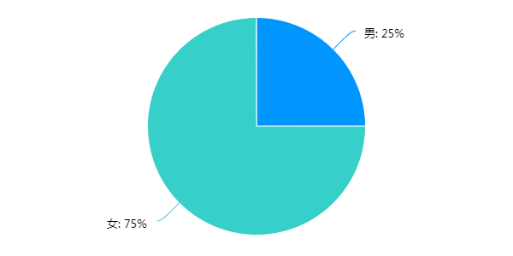

The results of the questionnaire analysis based on user experience are as follows:

9.1 Results

From Table 9-1, it can be seen that Mean and Variance in six dimensions, the average value of each dimension is positive, indicating that users have a better experience of the use of the system in these six aspects. From the value of Variance, the questionnaire data has better consistency.

Table 9-1



The average value of each item can be seen in Figure 9-1. It is clearly visible in the figure that the average value of each item is positive, which also shows that the user's overall experience of using the system is positive.

Figure 9-1

As can be seen from Table 9-2, the survey users' evaluation of the three aspects of the system's Attractiveness, Pragmatic Quality, and Hedonic Quality is relatively good, in order of Attractiveness, Pragmatic Quality and Hedonic Quality. The system can be further designed to improve Hedonic Quality so that users get a better experience in this regard.

Table 9-2

|  |  |
| --- | --- |
| **Pragmatic and Hedonic Quality** | |
| Attractiveness | 1.72 |
| Pragmatic Quality | 1.62 |
| Hedonic Quality | 1.45 |

9.2 confidence intervals

As can be seen from Table 9-3, Here the 5% confidence intervals for the scale means are shown. The confidence interval of the six dimensions is in the range of 1 ~ 2, and the confidence interval of Efficiency is the smallest, so it can be seen that the user The system's Efficiency view is the most consistent.

Table 9-3

|  |  |  |  |  |  |  |
| --- | --- | --- | --- | --- | --- | --- |
| **Confidence intervals (p=0.05) per scale** | | | | | | |
| **Scale** | **Mean** | **Std. Dev.** | **N** | **Confidence** | **Confidence interval** | |
| **Attractiveness** | 1.717 | 0.852 | 20 | 0.373 | 1.343 | 2.090 |
| **Perspicuity** | 1.725 | 0.633 | 20 | 0.277 | 1.448 | 2.002 |
| **Efficiency** | 1.600 | 0.625 | 20 | 0.274 | 1.326 | 1.874 |
| **Dependability** | 1.525 | 0.765 | 20 | 0.335 | 1.190 | 1.860 |
| **Stimulation** | 1.513 | 0.741 | 20 | 0.325 | 1.188 | 1.837 |
| **Novelty** | 1.388 | 0.937 | 20 | 0.411 | 0.977 | 1.798 |

9.3 Answer Distributions

It can be seen from Figure 9-2 that among the proportions of the distribution of the answers from "1" to "7", the proportions of "5" and "6" in each of the 26 questions are the highest. Choose "2" and The proportions of "3" are all small, and "1" is hardly selected. It can be seen that the overall experience level of the user on the system is at the middle-upper level.

Figure 9-2

9.4 Benchmark

Benchmarking the data yields Table 9-4 and Figure 9-3. As can be seen from the diagrams and tables, the system's Comparison to benchmark in the six dimensions of Attractiveness, Perspicuity, Efficiency, Dependability, Stimulation, and Novelty are Good, and the Stimulation dimension is closest to the Excellent, Perspicuity and Dependability dimensions, which have just reached the Good level. Make systematic improvements in these two dimensions.

Table 9-4

|  |  |  |  |
| --- | --- | --- | --- |
| **Scale** | **Mean** | **Comparisson to benchmark** | **Interpretation** |
| **Attractiveness** | 1.72 | **Good** | 10% of results better, 75% of results worse |
| **Perspicuity** | 1.73 | **Good** | 25% of results better, 50% of results worse |
| **Efficiency** | 1.60 | **Good** | 10% of results better, 75% of results worse |
| **Dependability** | 1.53 | **Good** | 10% of results better, 75% of results worse |
| **Stimulation** | 1.51 | **Good** | 10% of results better, 75% of results worse |
| **Novelty** | 1.39 | **Good** | 10% of results better, 75% of results worse |

Figure 9-3

9.5 Inconsistencies

As can be seen from the table, there are three questionable items in the questionnaire data filled by one user, two questionable items in the questionnaire filled out by one user, and one questionnaire in the questionnaire filled out by six users. Overall credibility and consistency.

Table 9-5

|  |  |  |  |  |  |  |
| --- | --- | --- | --- | --- | --- | --- |
| **Scales with inconsistent answers** | | | | | | |
| **Attractiveness** | **Perspicuity** | **Efficiency** | **Dependability** | **Stimulation** | **Novelty** | **Critical?** |
|  |  |  |  |  |  | 0 |
|  | 1 |  |  |  | 1 | 2 |
|  |  |  |  |  |  | 0 |
|  |  |  |  |  |  | 0 |
|  |  |  |  |  | 1 | 1 |
|  |  |  |  |  |  | 0 |
|  |  |  |  |  |  | 0 |
|  |  |  |  |  |  | 0 |
|  |  |  |  |  |  | 0 |
| 1 |  |  |  |  |  | 1 |
|  |  |  |  |  |  | 0 |
|  |  |  |  |  | 1 | 1 |
|  |  |  |  |  |  | 0 |
|  | 1 |  |  |  |  | 1 |
|  |  | 1 |  |  |  | 1 |
| 1 |  |  |  | 1 | 1 | 3 |
|  |  |  |  |  |  | 0 |
| 1 |  |  |  |  |  | 1 |
|  |  |  |  |  |  | 0 |
|  |  |  |  |  |  | 0 |

# 10.Final Design

Discuss details of the design refinement process and the final detailed design. Start with a system level description that flows down to the subsystem and component level.

1. Eter has a login interface and four first level pages, which are home page, community, evaluation and me.As shown in the figure below.Every pages has its second pages,the total quantity of them are 45.

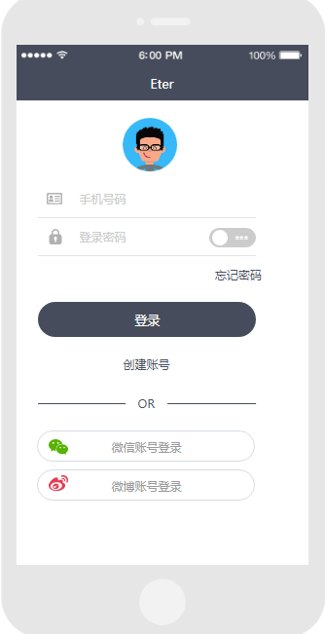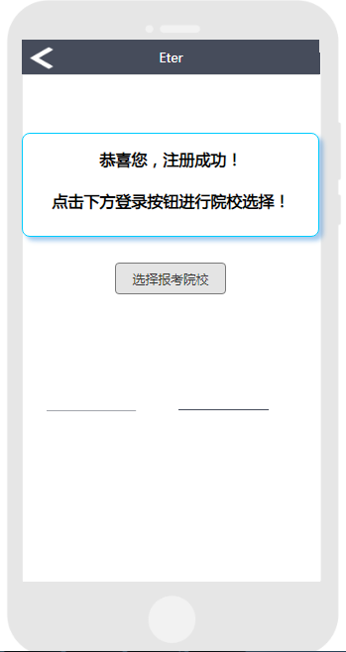

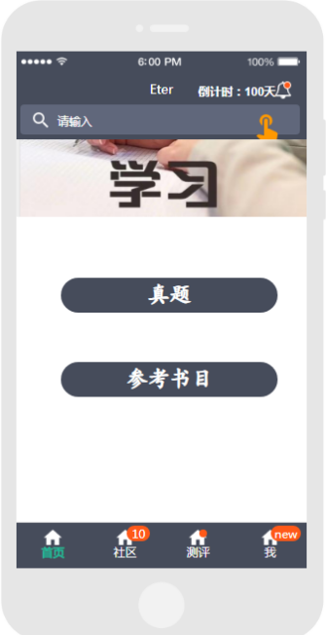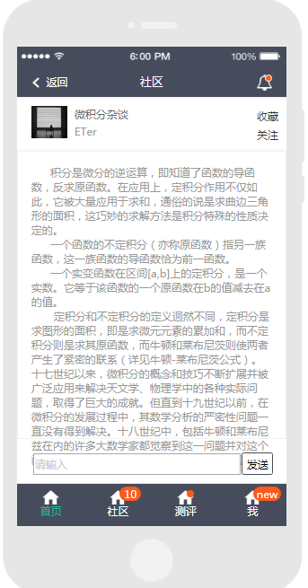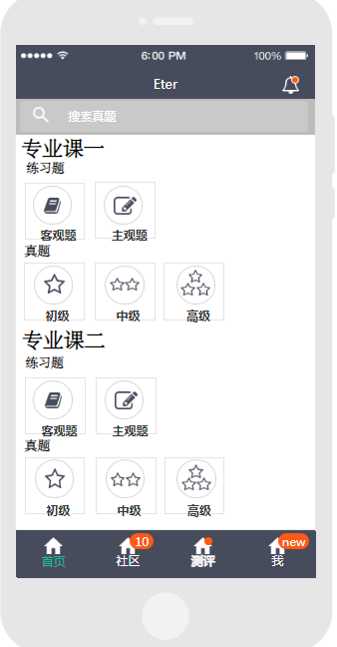

2)Special founctions includes college selection,knowledge point push,concept map and so on.

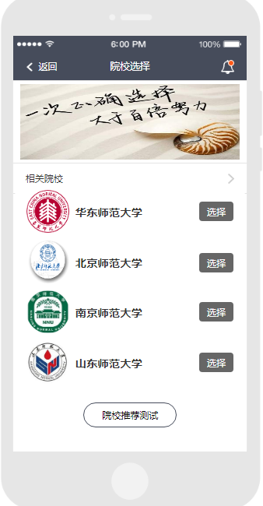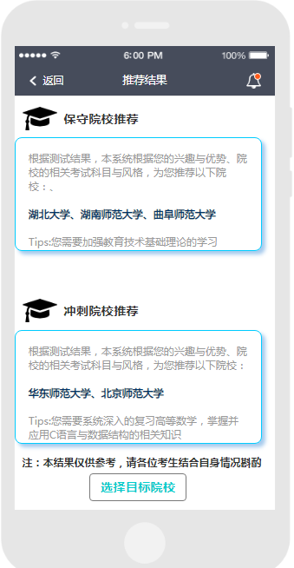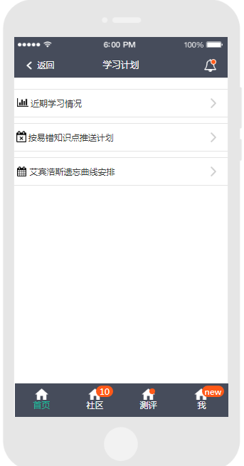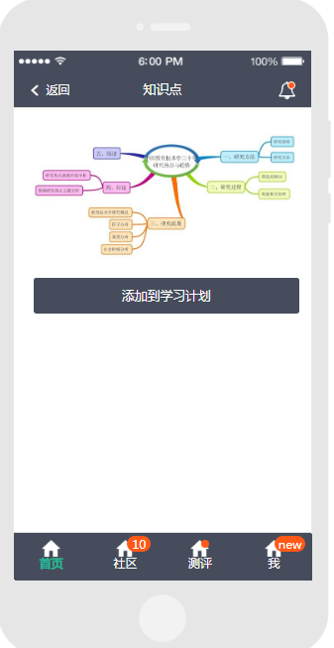

# 11.Conclusions

Our project surely meet the objective by designing a good solution to the business opportunity and respond to the original needs statement.

1. ETer as a software to help the postgraduate students majoring in educational technology are scarce in the market. The number of postgraduate entrance examination every year is too many. As a secondary discipline of pedagogy, educational technology has obviously not received the attention of the "postgraduate entrance examination group" that everyone is familiar with. So ETer just fill in this gap, which can be said to be the gospel of the students majoring in educational technology.

1. Our design objectives are based on user needs assessment, which can be divided into five dimensions: practicable,user friendly,content-rich,interactive and personal information management.As a customized software for postgraduates majoring in educational technology, the most exciting part of eter is its content richness and simulation test part, which we have designed emphatically.See Table 3 for details.

**Table3. Specifications**

|  |  |
| --- | --- |
| Requirements | Whether to achieve |
| **1.Practicable** |  |
| 1.1 Exercise bank | √ |
| 1.2 Simulation test | √ |
| **2.User friendly** |  |
| 2.1 Interface |  |
| F.1 Simple and clear interface | √ |
| F.2 Clear function button | √ |
| 2.2 Easy to use |  |
| 2.3 Privacy |  |
| 2.4 Self-knowledge construction |  |
| **3.Content-rich** |  |
| 3.1 The quantity of resources are guaranteed | √ |
| F.1 Previous examination papers | √ |
| F.2 Expert Introduction | √ |
| F.3 College information of the major | √ |
| F.4 Institutions Introduction | √ |
| F.5 Bibliography | √ |
| 3.2 Relevant links | √ |
| 3.3 Professional | √ |
| 3.4 The resources updated in time | √ |
| **4. Interactive** |  |
| 4.1 Able to search resources | √ |
| 4.2 Provide accurate resources for learners | √ |
| 4.3 Online discussion | √ |
| 4.4 Relevant recommendations | √ |
| 4.5 Help and feedback | √ |
| **5.Personal information management** |  |
| 5.1 Collect favorite contents | √ |
| 5.2 Able to take notes in the process of learning | √ |
| 5.3 Able to record of error correction | √ |

## Your contribution and self-evaluation

Wang lindeng:

I participated in the design and implementation of the group project throughout the process. During the project, I listened carefully to the suggestions of others and made some suggestions of my own. At the beginning, I and the other members of our team identified the project the team asked to design. In the later period, I was mainly responsible for the implementation of the home page and the home page sub-page, login and registration page, and feedback interface, the tasks of the fifth and sixth parts of the project report, and distributed some questionnaires, and sometimes integrated some of your work.

I try my best in this group, of course, sometimes I forget something, but the partners in the group will remind me in time, and thank them very much for their help. If you let me rate my contribution ratio, I will score 20 %, Because I think everyone is united, they are seriously completing their tasks, and they are doing their best to complete this project, so our contributions are the same.

Cao weina：

I was responsible for the "Test" module in the software and some pages in the "I" module . In the report, I was responsible for the Part 3 and Part 7, and Yankun and I were jointly responsible for Part 8. In addition, I was also responsible for the PPT and reporting of "learner analysis report". I think that I was responsible in the process of cooperation, and actively cooperated with other team members, and put forward a lot of my own views, such as proposing many techniques in our application to realize the analysis of learners' learning behavior, but there were still many shortcomings, such as my interface design was not as beautiful as other team members. Anyway, I'm satisfied with myself.

Qin yankun:

My contribution was to participate fully in all discussions and collaborations, to participate in the formation of ideas and solutions, and to make Suggestions, except for the absence of one discussion. Do the PPT. After the discussion, form a preliminary plan, do the second class report. After the demonstration of the changed project, I put forward the following Suggestions for the teacher's question of how to make students learn better:

1. According to the learning record, arrange the learning content (ebbinghaus) 2. According to the wrong questions, push 3 to my (learning plan). (purpose: to see the strength of students in the same school) 4. Sort out the outline of the book in the bibliography (mind map, knowledge point arrangement, knowledge point marking, and you can also click on the knowledge point for practice), and make changes to the project according to the Suggestions in the process of sharing with other groups.In the prototyping section in the first edition responsible for all parts of "me" except the collection altogether 10 pages. During the production of the second edition of the project, I was responsible for the main page of "me", the function page of wrong questions and the function page of learning plan. About our page, all the function pages set and the mind map in the bibliography were 11 pages in total.

On the composite version, the team worked together to modify the third version. Revise the fifth edition separately. Work with zhang yuxia to revise version 6 and 7. In the final design document, write parts 4 and 8. Participate in discussions on how all topics should be written and provide Suggestions and solutions. Invite students to experience the platform and fill in the questionnaire.

Zhang yuxia:

In this group project, I was mainly responsible for the production of college selection, ability tests, collections and other pages. After the entire prototype was completed, I was also responsible for several rounds of testing and modification of the prototype. In the subsequent user experience survey of the system, I was mainly responsible for making the questionnaire and finding users to experience our system and fill in the user experience questionnaire. Regarding the writing of the document, I am responsible for the introduction of the first part and the data analysis of the user experience questionnaire in the ninth part.

I have been actively involved in group collaboration throughout the entire group project. I will put forward some new ideas of myself, point out the problems and doubts of our project, and discuss with the group members. In the communication with the group members, I also often act as a contact to promote our group tasks.I learned a lot in the whole process.

Ouyang huiying:

In the process of ETer development, I  always discussed the design plan with other team members. The specific work is as follows: (1)Search for development software and corresponding mobile component library. (2) Design and implementation of “community” , “Error set” and “Note” of the app.(3)The writing of “Customer Needs Assessment” ，“Finally Design”and “Conclusion”. (4)Revision of interview guide and observation guide. (5)Actively participate in the completion of each group assignment.

 I actively participated in the app design of the group and learned a lot from this process.For example,I think the most important thing I learned is how to develop a product, from customer needs assessment to the final formation of the product, which is actually an iterative optimization process.And the position of learning theory in the whole product design is irreplaceable, which is also the guarantee that our learning platform can be recognized by professionals.In conclusion,I've made a lot of progress by actively participating in ETer design.

# References

[1] 国佳，陈华.大学生考研现状分析及相关的对策思考［J］.科学导报，2013(11).

[2] 方乐,陈文杰,王世纯,许新华,黄智聪,姜向龙.Android平台“考研ZHE联盟”App设计开发[J].福建电脑,2017,33(12):20-21+27.

[3] Muriru, P.K. and Daewoo, R., “Prediction of the Heat Transfer Characteristics of a Multi-Flame Injector'”, Combustion and Flame, vol. 100, no. 2, pp. 123-135, 2002.

[4] Peters, L., Johnson, M., and Davidson, K., “A Novel Approach to Four-Bar Synthesis'”, 10 Design Automation Conference, pp. 234-250, Pittsburgh, PA, 2001.

ASME

[5] Swanson Inc., “Online Users Manual for ANSYS 5.0'', <http://www.ansys.com/>manual, viewed on March 1999.

[6] Wen-Cheng, C., “Electric Bicycle'”, US Patent no. 5,368,122, November 29, 1994.

[7] Zacharia, M. and Daudi, P.K., The Effect of Multi-materials on Conventional Finite Element Formulations, New York: Wiley and Sons, 2001.

[8] Dong Xiaohui, Yang Xiaohong, Zhang Xuejun.Research Status and Prospects of Adaptive Learning Technology [J] .Research on Educational Technology, 2017,38 (02): 91-97 + 121.

[9] 百度百科.大数据技术[EB/OL].[2019-12-30].https://baike.baidu.com/item/大数据技术/23438668.

[10]51CTO.大数据方面核心技术有哪些?[EB/OL].[2019-12-30].http://bigdata.idcquan.com/dsjjs/159544.shtml.

[11]ADVISORS E G.Learning to adapt:A case for accelerating adaptive learning in higher education[EB/OL]. [2019-12-30].http://www.georgiacolleges.org/members/sm_files/Adaptive%20Learning%20Report.pdf.